Aim: To design and implement a simple conversational bot using Amazon Lex.
Theory:
- Amazon Lex:
A fully managed AWS service that lets developers build conversational interfaces using voice and text. It uses the same deep learning technologies that power Amazon Alexa.
- Core Concepts:
  - Bot: The conversational agent itself.
  - Intent: Represents the goal of the user (e.g., BookTable, GetWeather).
  - Utterances: Example phrases the user might say to trigger an intent.
  - Slots: Parameters Lex captures from user input (e.g., date, time).
  - Fulfillment: The response or backend action Lex performs once all slot data is collected.
- Integration:
Lex integrates seamlessly with AWS Lambda, Amazon Connect, and AWS Polly to build voice-enabled, intelligent chatbots.

Procedure:
Step 1: Open Amazon Lex Console
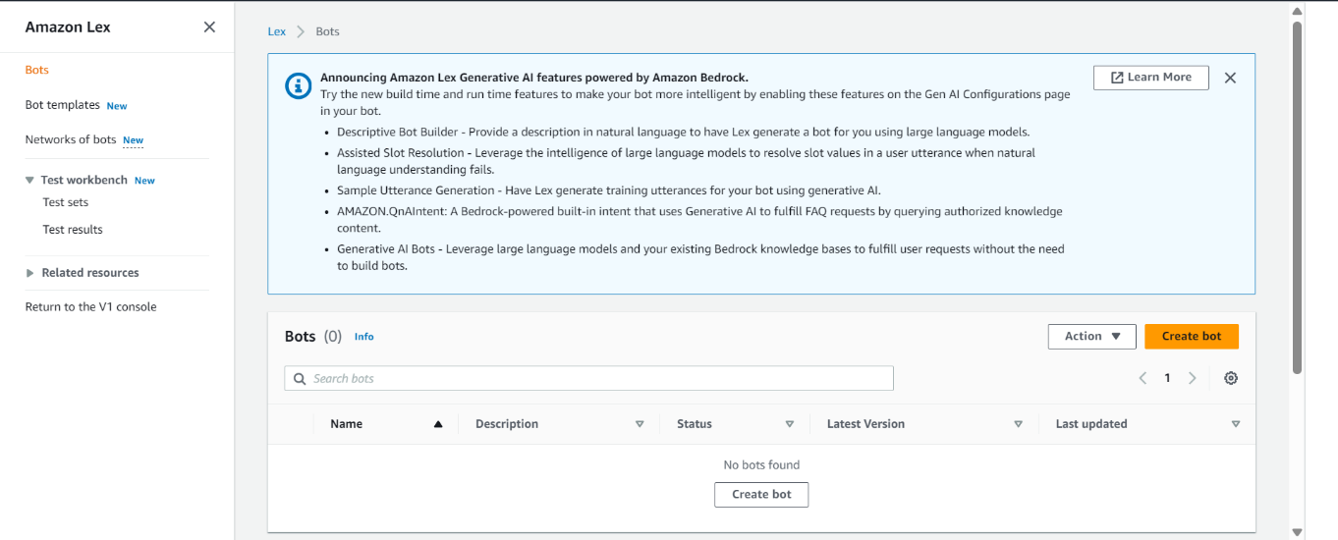
- In the AWS Management Console, search for and open Amazon Lex..

- Choose Create bot → Create bot from scratch.
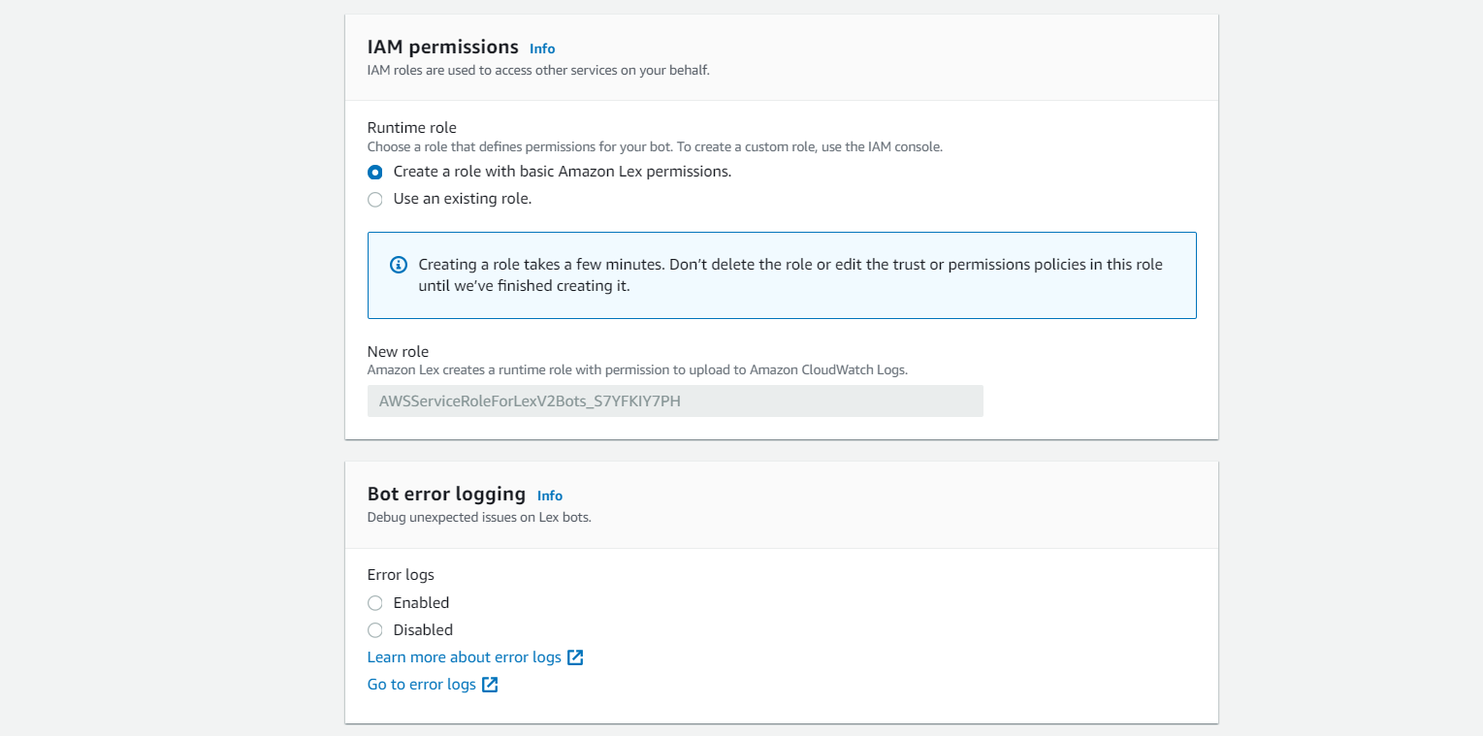
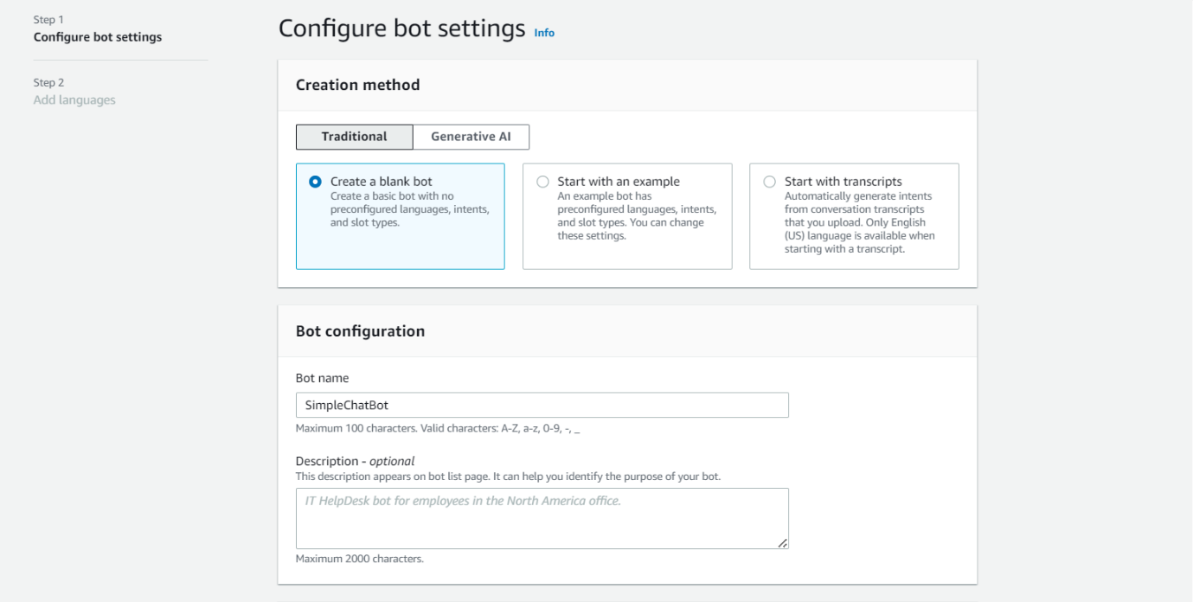
- Enter:

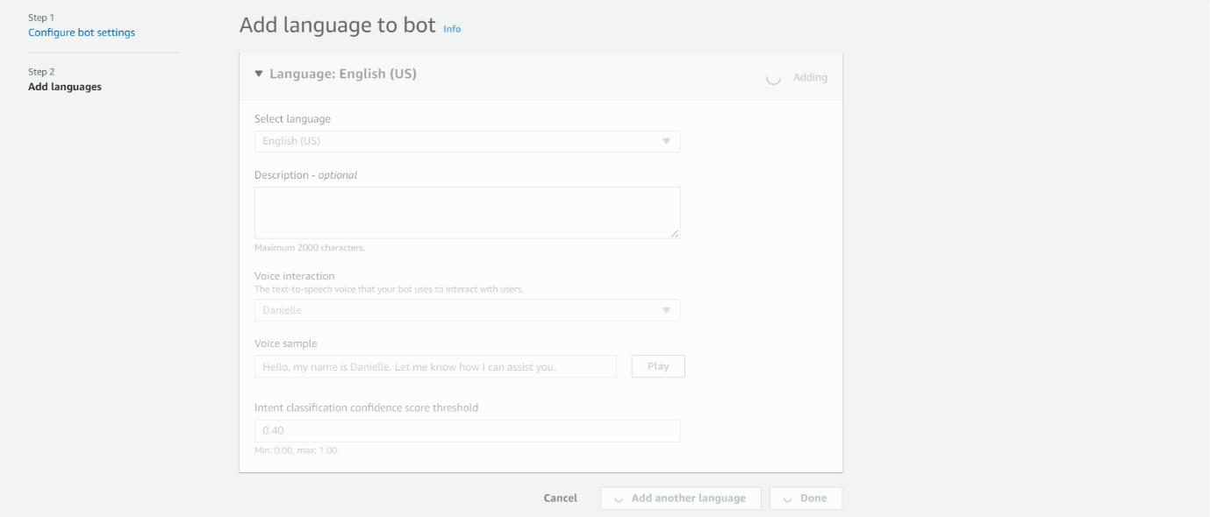
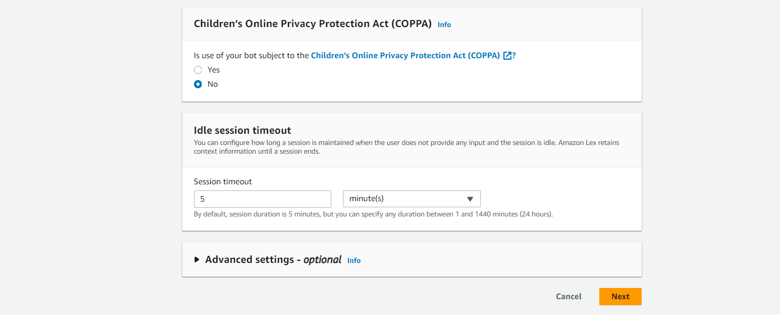

After the bot is created:
Step 2: Create an Intent
- Under your bot, choose Add intent → Create intent.
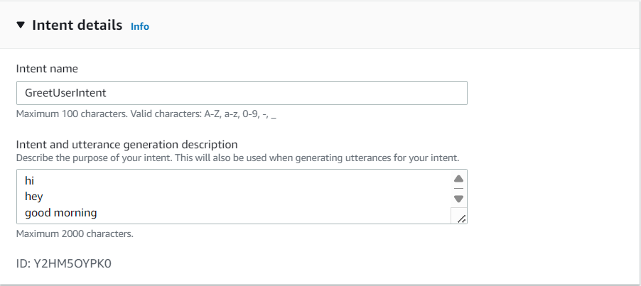
- Name it GreetUserIntent.

- Add sample utterances, such as:

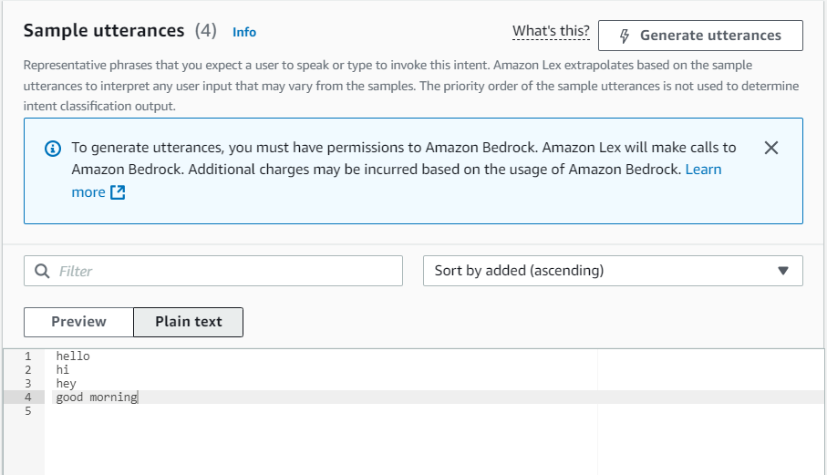

- In the Response section, add:
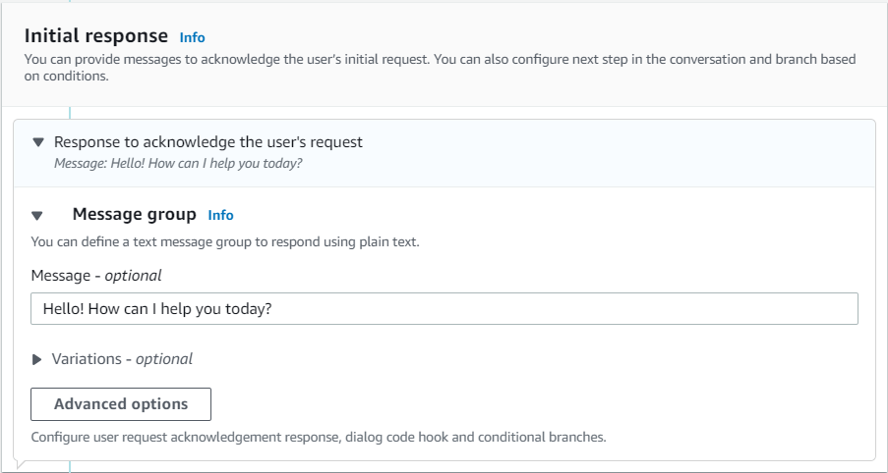
- Save the intent.
Step 4 : Build and Test the Bot
- Click Build in the top right to compile the bot configuration.
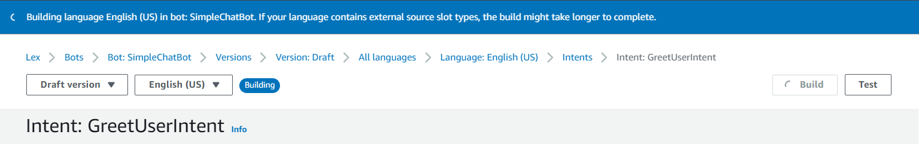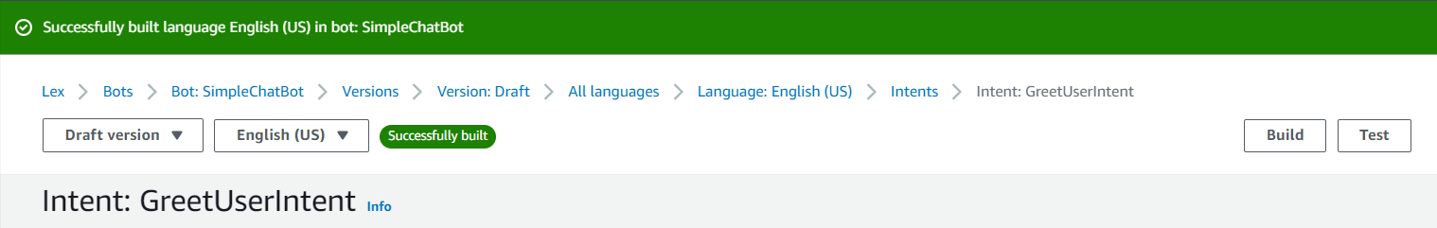

- Once the build completes, click Test on the right panel.
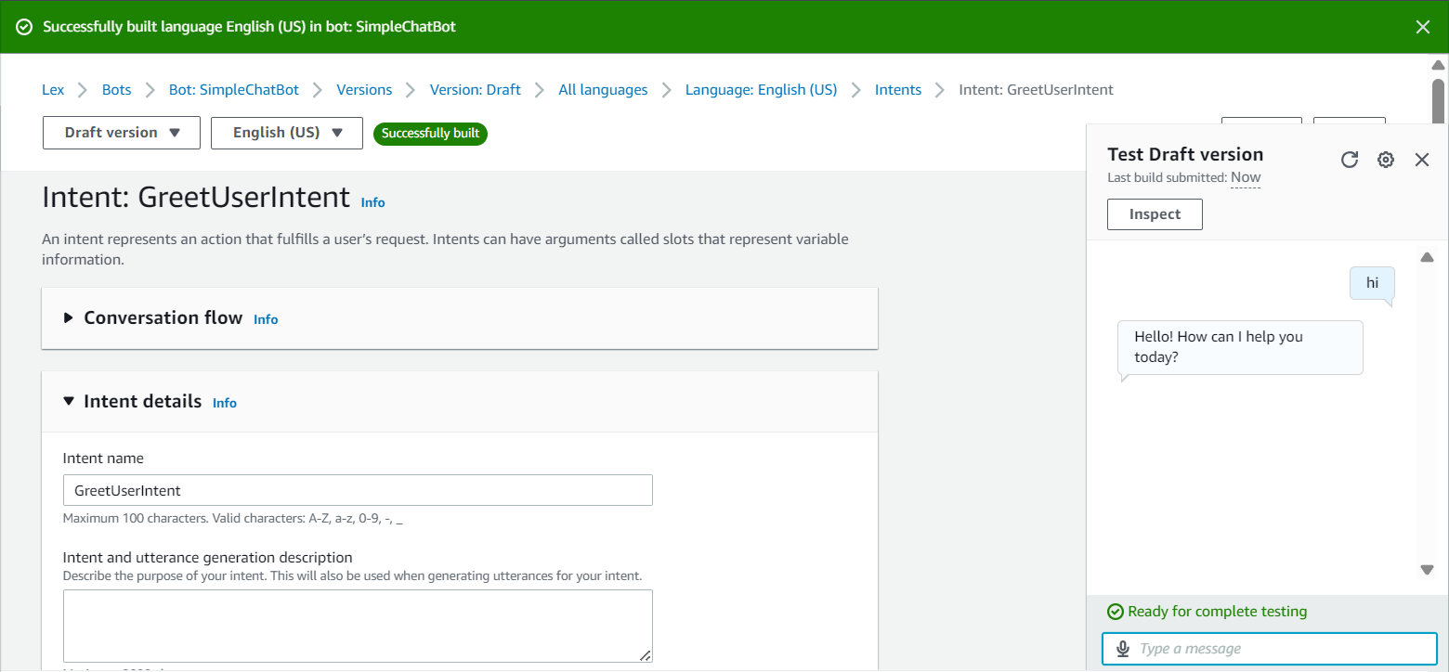
Conclusion:
In this lab, we successfully designed and implemented a simple conversational bot using Amazon Lex.
The bot recognized user greetings and weather-related queries, responded intelligently, and optionally integrated with AWS Lambda for dynamic content generation.
This exercise demonstrates how natural language understanding and cloud-based AI services can be used to build interactive conversational systems with minimal coding.

